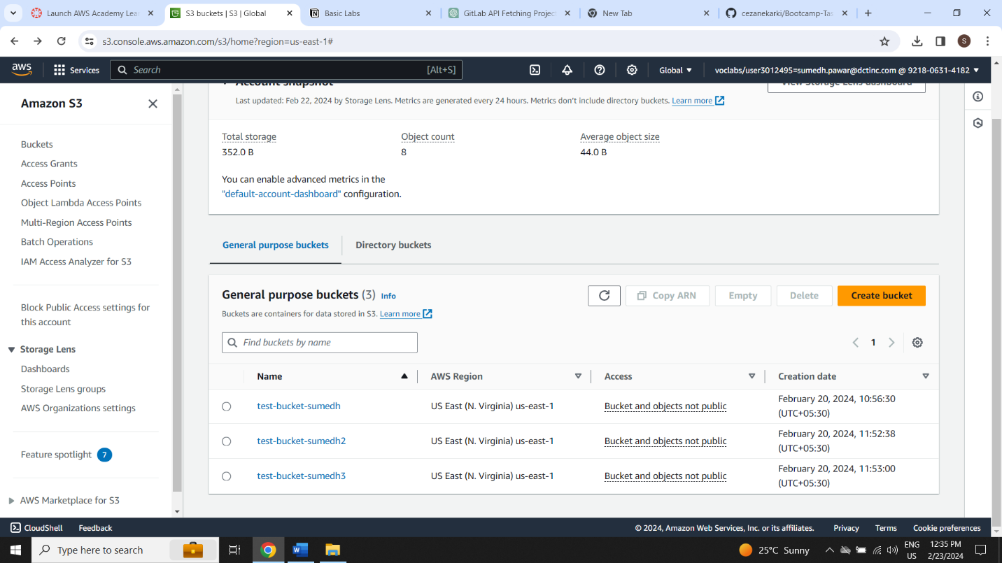

3 buckets created and have got the understanding how to use S3 for storing and managing data